Name___________________ Date_____/_____/_____

**Activity Sheet 1**

Match The devices to their names:

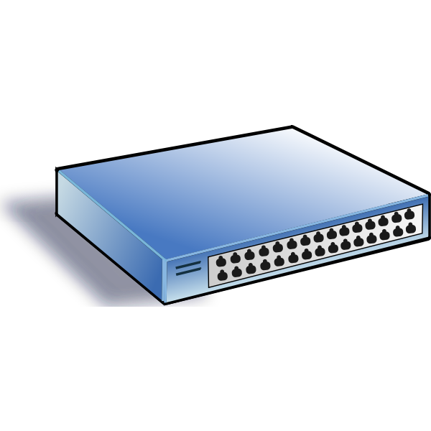

Router

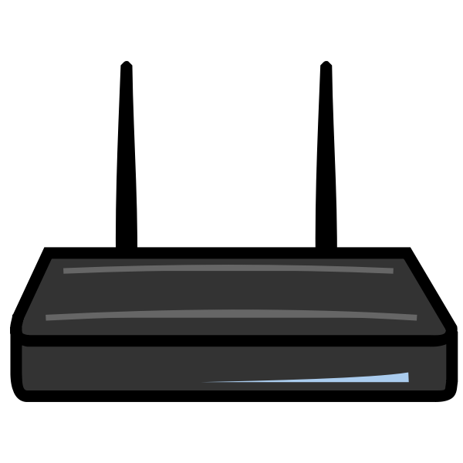

PC



Switch



Internet